Environmental Planning and Assessment Act 1979

Burwood Local Environmental Plan 2012 (Amendment No 23)
Burwood Council
2 Conder Street
Burwood NSW 2134

Map Cover Sheet

The following map sheets are revoked:

Map Sheet | Map Identification Number
Heritage Map  HER_002 | 1300_COM_HER_002_010_20170828

The following map sheets are adopted:

Map Sheet | Map Identification Number
Heritage Map  HER_002 | 1300_COM_HER_002_010_20220707

Certified

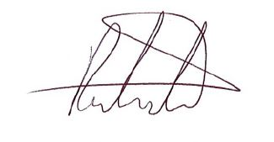

Dylan Porter Date 12/07/2022
Director City Strategy
As delegate of Burwood Council, the local plan making authority.

1300_COM_MCS_20220707 Page 1 of 1

